Name : Fariha Arai

AF ID : AF0443236

Lab 3

**1. Using input() function take one number from the user and using ternary operators check whether the number is even or odd.**

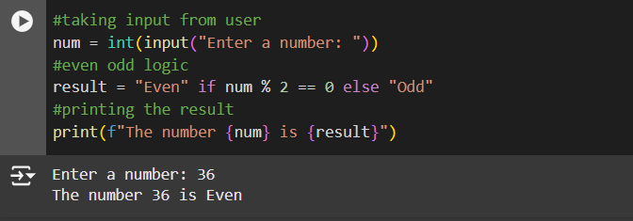

**2. Using input function take two number and then swap the number.**

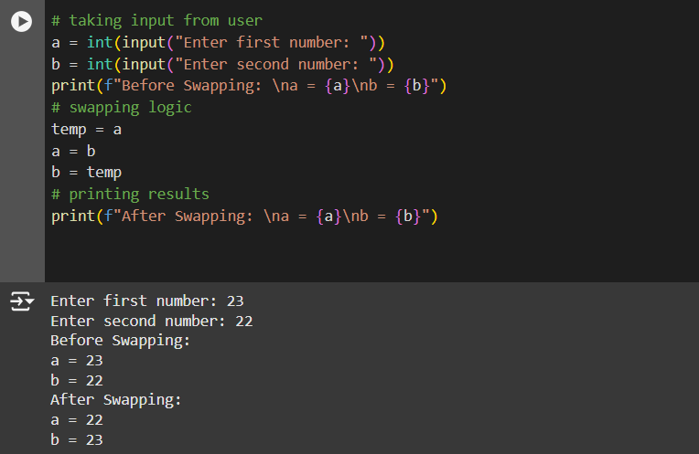

**3. Write a Program to Convert Kilometers to Miles.**

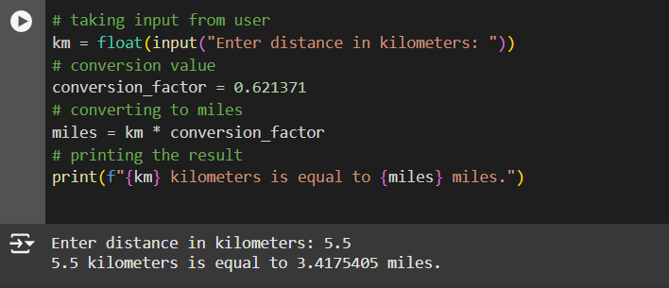

**4. Find the Simple Interest on Rs. 200 for 5 years at 5% per year.**

